How Students sign into the Student Portal using “Magic Link” No more remembering Usernames or Passwords!
Use this guide to assist Students with logging in to the Student Portal. This process involves;
- School ID - 12970
- Student school email address

1 | Download the Bromcom Student App on their phone and select to log in using the Magic Link.  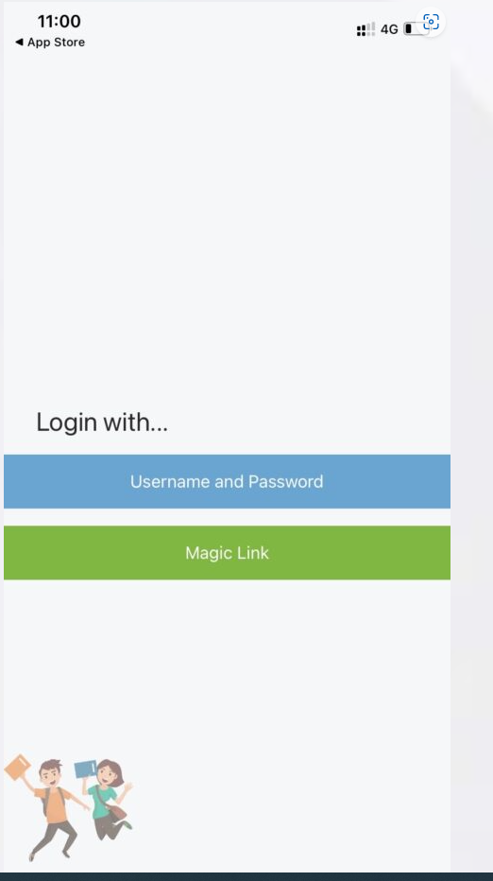
2 | The Student would then enter the School ID 12970 and their Single Sign on Email ( school email address):  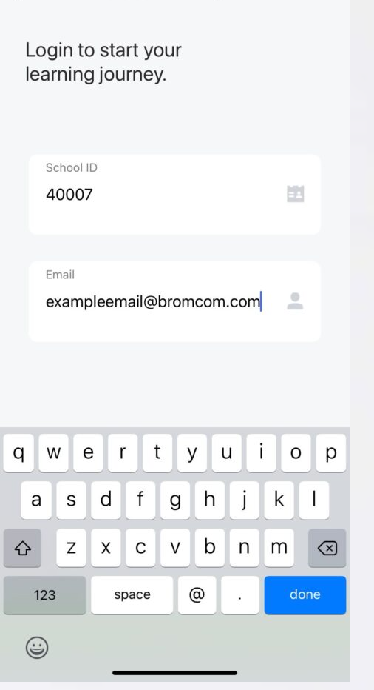
3 | Once the School ID and Email have been entered, the App will state that a Magic Link has been sent to their Email Address.  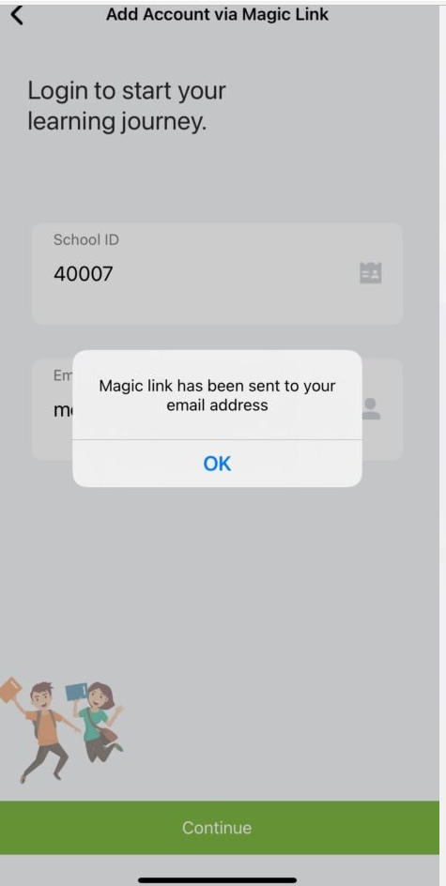
4 | Using an Internet browser, open Microsoft Office 365 on the phone  Enter Pupil school email address for example: fred.bloggs@thetauntonacademy.com  Enter password: this is the password the pupil uses to log on to the school computer.  When asked to go to the “authenticator app” select “use different method”, select “phone” from the dropdown menu and enter the mobile phone number of the phone you are using. A passcode will be sent via “messages” and can be entered in Outlook.  Below is an example of how the Email containing the Link will arrive to the Student, which they would then click to open (the link may appear as along list of text/characters)  Note: Students MUST open the Magic Link Email from a DEDICATED EMAIL APP on the Mobile Phone/Device that the Student Portal App is also installed on.  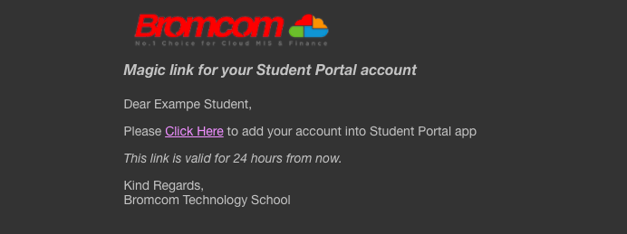  Clicking this link will enable Students to use Single Sign for the Student Portal and bypass  the need to enter credentials moving forward.  From now on, when Students log in to the Student Portal either via the Web or App Version, the App will take them straight through after they enter their 5 digit code or use Face/Touch Recognition while the Web Version will take them straight through after they select Login with Microsoft as seen below;  